VAANP CME EVENT
Pharma & Botanicals for Pain and Trauma + Ethics
Saturday November 10th, 2018
VAANP Members $100 | Non-members $150
Attend in person OR via live streaming
9:45 AM – 5:30 PM
www.vaanp.org
6.00 CME credits approved for Nurses (RNs & NPs via *Western Multi-State Division)
*Western Multi-State Division, an accredited approver by the American Nurses Credentialing Center's Commission on Accreditation.

Course Details:
Rodney Adams, Esq will present on medical ethics and case studies involving pain management in the midst of the opioid crisis. Marybeth Babos, PharmD present on pharma for several types of non-cancer pain conditions (ie headaches, orthopedic pain, nerve pain, etc) with emphasis on pharmaceutical approaches, standards of care/ best practices, concerns/ considerations in the midst of the opioid crisis, botanical considerations, and drug-herb/ drug-nutrient interactions. Leah Hollon, ND, MPH will discuss the pathophysiology, specific therapies and maintenance support that serve to unwind the sequelae of trauma and more specifically, PTSD.

Presenter: Leah K. Hollon, ND, MPH

Title: Unwinding PTSD and Trauma: Unique Perspectives in Pathophysiology, Therapeutics and Maintenance

Presentation Description: Trauma and more specifically PTSD lead to neurological, hormonal and immunological disturbances within the system. By way of complex forces including childhood development, epigenetics and the environment the trifecta can serve as an entryway impacting methylation, cell signaling and self-recognition. PTSD specifically changes methylation but what risk factors exist and what can be done for potential prevention and therapy? Within this session, we will discuss the pathophysiology, various therapies and maintenance support that serve to unwind the sequelae of trauma and more specifically, PTSD. Current supportive literature and research will be shared to provide insight and therapy for PTSD and trauma though pharmacotherapy, pharmacognosy, homeopathy, nutrition, and lifestyle support. The session will consist of lecture and case based learning.

Relevant Topics Include: PTSD/Trauma, Epigenetics/methylation, Anxiety and Depression, Homeopathy, Endocrine System, Neuro-Immunology, Human & Childhood Development, Sleep Disorders, Pharmacotherapy, Pharmacognosy and Lifestyle Approaches, Counseling and Somatic Based Therapies

Presenter: Mary Beth Babos MS PharmD BCPS

Title of presentation: “Pain: an intersection where pharmaceuticals and botanicals meet”

Objectives:
- Relate pharmacologic actions of federal legend medications used in non-cancer pain management to their physiologic effects.
- Review the evidence underlying the current practice standards for use of federal legend medications in the management of non-cancer pain.
- Recognize and manage clinically significant botanical/legend drug interactions involving drugs used to treat pain.

Abstract: According to a 2012 survey, more than 10% of the adult population in the United States suffers from daily pain. While opioid medications do play an important role in managing this pain, their misuse and abuse is a serious crisis that causes the death of more than 115 people in the United States each day. The current “biopsychosocial” treatment paradigm for chronic pain calls for treatment that is multimodal and interdisciplinary . In this paradigm, naturopathic physicians are uniquely situated to play a pivotal role in reducing the burdens of both pain and prescription drug abuse. A common language is necessary to optimize the function of the interdisciplinary team. The aims of this activity are to review the pharmacology of pain management as a unimodal approach, to explore the pharmacology of the federal legend drugs currently employed in the best practice of pain pharmacotherapy, and to examine the points at which botanical and federal legend treatments interact.

Presenter Bio’s

Rodney K. Adams
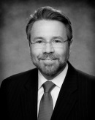

Biography

Mr. Adams focuses his practice on advising and defending health care providers in matters involving patient care and other unique issues confronting the healthcare industry. His guidance, whether during a strategic discussion or during a crisis, is based on his extensive trial and agency adjudication experience. Mr. Adams’ clients include physicians, psychologists, hospitals, managed care organizations, medical colleges, nursing homes, self-insured health systems and other healthcare providers. He has spent thirty years defending healthcare providers and has taken over seventy-five medical malpractice matters to verdict. Most of those matters involved catastrophic injury or death. He also represents healthcare providers before the U.S. Office of Civil Rights, various boards of the Virginia Department of Health Professions and other tribunals.
In addition to defending healthcare providers, Mr. Adams also defends manufacturers and distributors in product liability actions, especially with regard to medical product liability. Breast implants, pedicle screws, fen-phen, latex, and asbestos are a few examples of his broad experience over the years.
Mr. Adams is well known for his work in bioethics, clinical research regulation, behavioral health law, healthcare information privacy, and risk management. He has published several books including Virginia Medical Law, Fourth Edition (2016), and Clinical Trials & Human Research: A Practical Guide to Regulatory Compliance (w/F. Rozovsky, 2003). Mr. Adams is an adjunct professor of law (medical malpractice trial advocacy) at the College of William & Mary, and an adjunct professor (bioethics and health law) at the School of Health Administration, Virginia Commonwealth University. Clients look to Mr. Adams for assistance with HIPAA/HITECH, LEP, EMTALA, ethics committees, medical staff issues, and other healthcare management issues.
As leader of LeClairRyan’s Professional Liability Team, Mr. Adams supports the Firm’s attorneys across the United States who defend and counsel accountants, attorneys, architects, engineers, directors, officers, healthcare providers and other professionals.

Mary Beth Babos, RPh, BS Pharm, PharmD, CDE
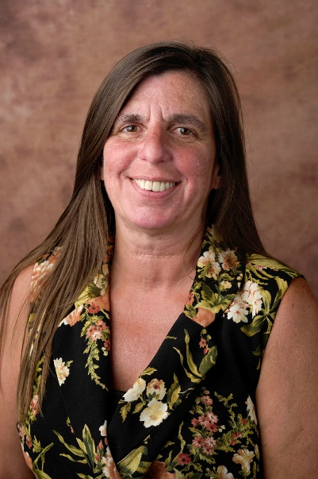
Biography

Mary Beth Babos, MS, PharmD, BCPS obtained her B.S. degree in pharmacy from Duquesne University in 1985. She received a PharmD from Union University, Albany College of Pharmacy in 2001, a MS in Forensic Toxicology from University of Florida in 2009, and a MS in Pharmaceutical Chemistry from the University of Florida in 2011. She completed the certification program from Eclectic School of Herbal Medicine in 2018. Dr. Babos is currently Professor and Chair of Pharmacology at DeBusk College of Osteopathic Medicine, Lincoln Memorial University in Harrogate, TN. She serves Hancock County Tennessee as clinical pharmacist through Ballad Health Hancock County Hospital and is a faculty advisor for the First Aid Basic Science™ series. Her current research is focused on the medicinal and ethnoveterinary uses of plants in the Ridge and Valley and Blue Ridge Mountain regions of Appalachia.

Leah Hollon, ND, MPH
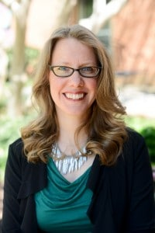
Biography

Dr. Leah Hollon holds a BS in Psychology from Virginia Commonwealth University (VCU) and a Master in Public Health (MPH) from VCU School of Medicine. Dr. Hollon completed her ND degree and residency training at NUNM. She has also served as an Assistant Professor of Pharmacy and is a co-owner of Richmond Natural Medicine. She has been an editor for the American Journal of Pharmaceutical Education (AJPE), has been published in the use of alternative medicine and assisted in the establishment of a drug court program in Central Appalachia. Her time within Appalachia led to tailored support for PTSD, where today the bulk of her patients’ present with unresolved trauma or PTSD. She has worked within the field for 18 years, where some of her earliest research was completed within a level 1 trauma center. During this time, she assisted a team of forensic nurse examiners (FNEs) to address the trends of intentional injury within the emergency department in order to develop future methods of prevention. Additionally, she is passionate about fostering and encouraging the development of future clinicians, where she serves as the residency site coordinator for the first accredited naturopathic residency in Virginia. She has also presented nationally and internationally within her discipline for the ASCP (American Society of Consulting Pharmacists), UNC, EVMS, VCOM, AANP and the ICNM.

Nahin RI. Estimates of Pain Prevalence and Severity in Adults: United States 2012. Journal of Pain. 2015;16(8): 769-780.
CDC/NCHS. National Vital Statistics System. Mortality. CDC Wonder; Atlanta, GA; US Department of Health and Human Services, 2017. Accessed at https://sonder.cdc.gov on June 25, 2018.
Dale R, Stacey B. Multimodal Treatment of Chronic Pain. Med Clin N Am. 2016; 100: 55-64.
American Society of Anesthesiologits Task Force. Practice Guidelines for Chronic Pain Management. Anesthesiology. 2010; 112(4):1-24.

